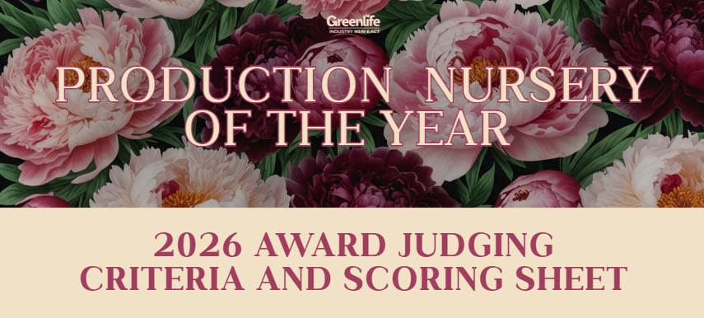

Eligibility
Applicants must be members of the GINA

Judging Process
- Stage 1: Remote Judging of Application
- Stage 2: Onsite Judging
- Stage 3: Peer Judging
Note: Only finalists progress to Stage 2 and 3.

1 = Extremely Poor, 2 = Very Poor, 3 = Poor, 4 = Fair, 5 = Satisfactory, 6 = Satisfactory Plus, 7 = Good, 8 = Very Good, 9 = Excellent, 10 = Exceptional.

STAGE 1 JUDGING – Remote

Category 1: Marketing & Customer Communication
 | Criteria | Score  (1-10) | Comments
1 | Development and implementation of a clear marketing strategy with defined objectives and consistent branding across customer touchpoints
2 | Effective use of communication and marketing channels to promote the business and connect with customers (website, email marketing, social media, EvergreenConnect, trade events, direct customer contact)
3 | Professional digital presence through a well maintained website, online accessibility and effective customer enquiry management systems
4 | Effective communication of stock availability, new product lines and seasonal updates through consistent and accessible customer communication systems
5 | Use of digital marketing tools and measurement systems to track marketing performance, customer engagement and business outcomes

Category 2: Business Operations and Workforce Management
Criteria |  | Score  (1–10) | Comments
6 | Demonstrates well structured operational systems, documented procedures and processes that support efficient, consistent and high quality day to day production and sales activities
7 | Clearly defined roles, responsibilities and internal communication systems that support team alignment, operational consistency and effective business operations
8 | Demonstrates strong human resource management practices including employment compliance, workplace policies, workplace health and safety procedures, and employee wellbeing initiatives
9 | Commitment to staff development through training, professional development opportunities and building technical nursery knowledge, production capability and operational competency within the team
10 | Demonstrates effective performance management systems, regular staff reviews, career development opportunities and a clear commitment to long term workforce development

Category 3: Planning, Performance and Sustainability
Criteria |  | Score  (1–10) | Comments
11 | Development and implementation of documented short term and long term business planning, demonstrating clear strategic direction and future business growth planning
12 | Establishment and regular monitoring of key performance indicators (KPIs) or benchmarks used to measure productivity, operational efficiency, profitability and overall business performance
13 | Demonstrates innovation and continuous improvement through business improvements, infrastructure investment, technical upgrades, new systems or strategic operational changes implemented within the past 12 months
14 | Demonstrates commitment to sustainable business practices through environmental management initiatives, resource efficiency and sustainable operational practices implemented across nursery operations
15 | Engagement with the wider horticulture industry, local community, education providers or industry associations through partnerships, support, industry participation or knowledge sharing

STAGE 2 JUDGING - ONSITE

Site visit to verify and assess practical implementation of below criteria.

Category: Technical Production Aspects
Criteria |  | Score  (1-10) | Comments
16 | Compliance with industry best practice and standards (e.g., NIASA, EcoHort, BioSecure HACCP, AS2303)
17 | Crop management practices, including fertilisation, pruning, and cultivation techniques
18 | Management of environmental factors: light, humidity, temperature
19 | Crop hygiene practices to prevent pests and diseases
20 | Water and irrigation management including efficiency, conservation, recycling
21 | Soil/media management for optimal plant health
22 | Integrated management: IPM, ICM, IFM, AWM practices
23 | Monitoring KPIs and regular crop performance assessment
24 | Maintenance schedules and execution for equipment/infrastructure
25 | Documentation of processes, evidence of adherence, continuous improvement
26 | Established and documented quality standards
27 | Adoption of new technologies (automation, smart farming tools)

Category: Ethical Standards and Considerations
Criteria |  | Score  (1-10) | Comments
28 | Transparency and open communication with suppliers regarding pricing, terms, and conditions, and strives to build long-term, mutually beneficial relationships.
29 | Nursery prioritises sourcing practices that promote sustainability, such as seeking suppliers who adhere to environmentally friendly production methods or offer responsibly sourced materials
30 | Maintains a safe and healthy work environment for its employees, taking appropriate measures to prevent accidents, provide necessary safety equipment, and comply with occupational health and safety regulations.
31 | Sustainable operational practices (water use, recycling, pest management)

Category: Environmental Management
Criteria |  | Score  (1-10) | Comments
32 | Efficient and responsible water management practices
33 | Sustainable chemical use minimising environmental impact
34 | Proper waste management, including plastics and other materials
35 | Energy use optimisation and implementation of energy-saving practices.
36 | Impact assessment and mitigation for biosecurity, weeds, pests, diseases
37 | Waste minimisation through improved practices
38 | Use of sustainable inputs and materials
39 | Risk register management and preparedness plans including potential social, environmental, and operational risks.
40 | Contribution to carbon footprint reduction and climate resilience strategies

STAGE 3 – Peer Judging (Finalists Only)

The peer judging stage of our Production Nursery Award assesses how well nurseries foster respectful, trustworthy relationships not only with suppliers but also with their retail customers, uphold ethical business practices such as timely payments, and provide an overall positive business experience. Peer evaluators score these areas through structured surveys, ensuring the judging process reflects the nursery’s reputation, professionalism, and integrity within the industry.

