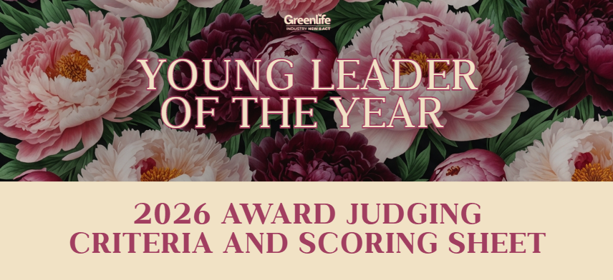

About the Award

This award recognises an outstanding young professional (aged 35 or under) who demonstrates initiative, leadership, integrity and vision within the nursery and garden industry. The award celebrates emerging talent and encourages future industry leadership.

Eligibility
- Nominee must work for a GINA member
- Nominee must be aged 35 or under (as of 1st December 2026)

Judging Process:
- Stage 1: Judging of Application
- Stage 2: Finalist Interview with Judges

Judging Criteria

Initiative and Leadership
 | Criteria | Score  (1-10) | Comments
1 | Demonstrates initiative and willingness to take responsibility within their workplace
2 | Shows leadership potential through decision making, ownership and accountability
3 | Demonstrates commitment to personal growth and future leadership within the industry
Category Subtotal |  | /30

Innovation and Problem Solving

 | Criteria | Score  (1-10) | Comments
4 | Has introduced new ideas, systems or improvements within the business
5 | Demonstrates strong problem solving and ability to improve operational efficiency
6 | Shows creativity and initiative when responding to workplace challenges
Category Subtotal |  | /30

Industry Engagement and Contribution

 | Criteria | Score  (1-10) | Comments
7 | Participates in industry events, training programs or professional development opportunities
8 | Contributes positively to the wider nursery and garden industry beyond daily role
9 | Demonstrates commitment to supporting the future growth of the industry
Category Subtotal |  | /30

People Leadership and Workplace Culture

 | Criteria | Score  (1-10) | Comments
10 | Leads by example and positively influences workplace culture
11 | Supports colleagues through mentoring, teamwork or knowledge sharing
12 | Demonstrates professionalism, integrity and strong workplace values
Category Subtotal |  | /30
Professional Development and Industry Knowledge

 | Criteria | Score  (1-10) | Comments
13 | Demonstrates commitment to continuous learning and skill development
14 | Shows strong understanding of nursery, retail or horticultural industry practices
15 | Invests in personal development to strengthen future career progression
Category Subtotal |  | /30

Business Impact and Results

 | Criteria | Score  (1-10) | Comments
16 | Has contributed measurable improvements within the business
17 | Demonstrates positive impact on operational performance, productivity or customer outcomes
18 | Contribution has delivered clear value to the business or team
Category Subtotal |  | /30

Final Interview Assessment

 | Criteria | Score  (1-10) | Comments
19 | Communication skills and confidence during interview
20 | Passion and commitment toward the nursery and garden industry
21 | Ability to clearly articulate achievements and leadership journey
22 | Demonstrated future leadership potential within the industry
Category Subtotal |  | /40

Judges will award up to 10 bonus points based on:
- Clarity and enthusiasm in sharing their story
- Alignment of values with industry goals
- Overall impression of future leadership capacity

